

Ministry of Forests

Interim Guideline

For

Rehabilitation and Recovery Data

Collection and Mapping

Contents
1. Scope 2
2. Purpose: 2
3. Field Data Collection 3
Avenza 3
Uses 3
Field Data Submissions 4
Photo Collection in Avenza 5
4. Data Migration from the Incident to Rehab 5
Status 5
Points 6
Incident Points 6
Rehab Points 7
Lines 8
Incident Lines 8
Rehab Lines 8
Polygons 8
High Priority Points/Lines 9
Maps/GIS Products 9
5. Data and Records Management 10
6. References, Resources and Links 11
7. Document History 11
8. Approvals 11

Scope
This document sets out the Spatial Data Standards for Rehabilitation and Recovery (rehab) mapping. This includes the migration of GIS data from Incident (OPS) into the rehab database; identification of the status of rehab data as it moves through the rehab process; display of rehab data, potential known safety concerns, and high priority/critical locations (e.g. archaeological sites and fish bearing streams). These standards provide a consistent process for field crews and GIS Specialists to follow, and acts as a stepping stone for automated field data collection with direct uploading into a spatial database in the future.

Purpose:
Consistent data management standards and practices are important for wildfire incident/rehab mapping. Consistency helps with incident/rehab staff turnover and creates a smooth transition for the incoming GIS Specialists. It allows rehab and GIS staff to work on multiple fires in different fire centres with consistent process, map symbology, and dataset structure. Consistency is also essential for summarizing rehab statistics by Fire Centre or Provincially. Spatial Data Standards for rehabilitation include:
- Standardized selection of incident data to be migrated into rehab database
- Standardized list of rehab treatments and definitions
- Standardized symbology
- Consistent rehab database standards
- Identification of high priority features that may require immediate attention.
- Rehab status of each feature (i.e. field verification required, field verification completed, treatment completed or obligations transferred)

Field Data Collection
Avenza software is the current method used to collect field data.

Avenza

Uses
Avenza allows a Rehab Specialist to:
- Import any PDF map, including those made by the GIS Specialist.
  - A large scale map (eg. 1:5,000) is recommended for field work.
  - A small scale map (eg. 1:30,000) can be useful as an overview and for navigation.
NB: Internet or cell coverage is required to import maps into Avenza and maps should be loaded before heading to the field. Once loaded, maps can be used without internet or cell coverage.
NB: User location shows up as a blue dot on the map.
- Create a KML to collect field data which may include:
  - Drop Points (using current location or marked location) with assigned attributes, descriptive text, and a photo.
  - Lines (using the draw and measure tool or by tracking your movements) with assigned attributes, descriptive text, and a photo.
- Utilize schema to enter data rather than manually entering the information.
  - When a point or line is created a drop down list is available to select the Rehab Treatment Type. This will reduce errors and speed up data collection.
  - The attached KML can be imported into Avenza and used for the collection of rehab treatment points and lines:

Point Symbology for Avenza (from e-mail export into Avenza)
Information regarding how to import and use KML Schema can be found in the reference Guides for Avenza.
- Export the data collected to the GIS Specialist via email as a KML, for map production/updating. (NB: Internet is required).

NB: Opening the collected data in Google Earth is useful for quality checking and cleaning up the data before submission, and/or for immediate use. An example of a Google Earth display is provided in the Naming Convention subsection (located within the Field Data Submission section) below.

Additional Information:
Instructions for Avenza and other tools can be found here:
  - Avenza Website
iOS
http://help.avenzamaps.com/customer/en/portal/topics/950368-avenza-maps-for-ios/articles
Android
http://help.avenzamaps.com/customer/en/portal/topics/951155-avenza-maps-for-android/articles

  - MOF Services Guides
\\spatialfiles.bcgov\work\!Shared_Access\Provincial_Wildfire_Rehab\Resources\GIS_Standards
Avenza is best used on an iPad or Android with an operating system of 6.0 or newer, as earlier versions may have a minor shift in the data when exported. Contractors will be responsible to purchase their own License through Avenza for the cost of $99.

BC Government employees can acquire Avenza Pro License code by contacting
NRS Maps at NRS.MAPS@gov.bc.ca

Field Data Submissions
Data Submission Requirements
Data should be submitted in KML format. All identified points and lines should be assigned actions that are planned to be undertaken in the field (or ‘No Treatment’). Fireguards should be captured in one track from start to end when the combination of treatments prescribed is the same along the entire length of the fireguard. Fireguards that have different treatment combinations over their length should be split into segments that reflect each unique treatment combination. Do not include additional data related to travel from one fireguard to another. Do not classify modified roads or heavily used roads as fireguards (even if they served this function during fire control operations). Fireguards with more than one type of treatment should have the spatial data collected only once, and then assigned the specific treatments as prescribed. If no actions are prescribed on a section of fireguard, the section should be identified as ‘No Treatment’ and a comment should be included that specifies the associated rationale. When adding a rehab point, use the KML provided or the options from the Rehab Points, and/or Rehab Lines treatment options. If adding missing incident data, use the correct Incident Line [FLType] classification.

Naming Convention:
The KML should be named with the date, followed by the action planned, the name of the person or client collecting the data, followed by a unique identifier.
For example: <YYYMMDD>_<Rehab Action>_<Name/Contractor Name>.KML
20180808_Seeding_JaneDoe_track1.KML.
Multiple KML’s can also be grouped into one by using Google earth to organize the data.

Example below was taken from Google Earth.
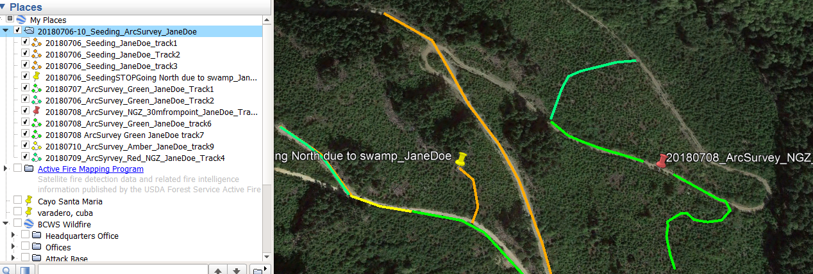

Photo Collection in Avenza
BC Government Employees should refer to the SOG Notebooks and Photos.

It is important that adequate georeferenced photos are taken by the Rehab Specialist, particularly for high risk areas. A naming convention that ensures that photos can be spatially matched with the corresponding feature in the rehab plan must be used.
Naming Convention:
Initial Photo File Name | Final Photo File Name Example
Incident # / Unique identifier / YYYMMDD / Initials of person who took photo | K20637 002 20180707 KN

Data Migration from the Incident to Rehab
Data migration involves moving selected data from the incident dataset into the rehab dataset, and may include points, lines, and polygons.

Status
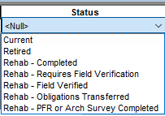
The rehab database has additional [Status] options. Different colour halo will help map users know what status a feature has.
- All features that are migrated into the rehab database will be given a [Status] of ‘Rehab - Requires Field Verification’.
- Once a Rehab Specialist has verified a feature in the field, the [Status] is changed to ‘Rehab - Field Verified’. The proposed Rehab Treatment (or ‘No Treatment’) should be assigned at the same time, and replaces the incident feature type in the display.
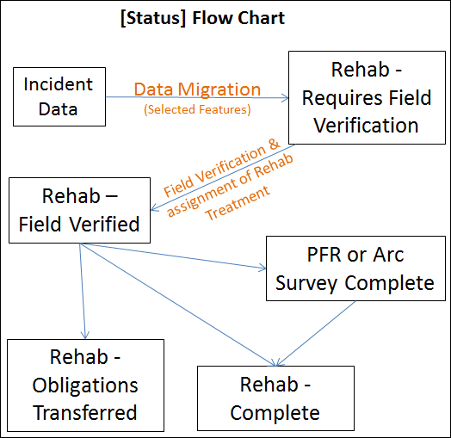
- Potential safety issues identified in the incident data (eg. No Work Zone, Hazard, Mine, etc.), should remain on the rehab map.
- NEW [Status] of ‘PFR or Arc Survey Complete’ might be required after the feature has been field verified and may occur before any rehab treatments can occur. PFR stands for Preliminary Field Reconnaissance.
- Once the rehab has been completed the point is given a [Status] of ‘Rehab – Completed’.
- If rehab is identified and is transferred to a third party, the point is given a [Status] of ‘Rehab – Obligations Transferred’. Some examples include: claims paid out rather than rehab work being actioned by BCWS, and a third party agrees to assume responsibility for the rehabilitation - usually because the party wants to use the access created by fire control for their own purposes (eg. BCHydro for power infrastructure repairs, Forest Licencee’s for salvage harvesting).

NB: Obligations Transfers should be supported with written documentation that relieves the Crown of any further obligation, and is properly signed-off by BCWS and the party taking on the obligation for rehabilitation. The rehab specialist should provide to the GIS Specialist with the legal name of the party taking on the rehab obligations and the effective date, so this information can be recorded in the GIS database.
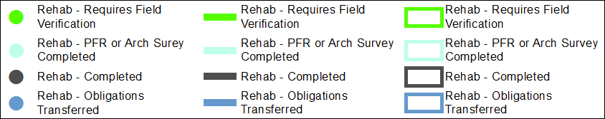

Points

Incident Points
The list on the left below shows the selected incident points that will be migrated into the rehab database. These selected incident point are only migrated if the [Status] is set to ‘Current’, with the exception of Camps and Staging Areas where ‘Retired’ points are also migrated over as they may have been disturbed and require field verification. Once a point has been migrated over into the rehab database from the incident database the [Status] will be set to ‘Rehab - Requires Field Verification’. Not all points well keep the original Symbology; many will be grouped into a Cleared Area category to simplify things. A green halo added around the symbol to show that it requires field verification by a Rehab Specialist. At that time they will decide if any Rehab treatment is required.
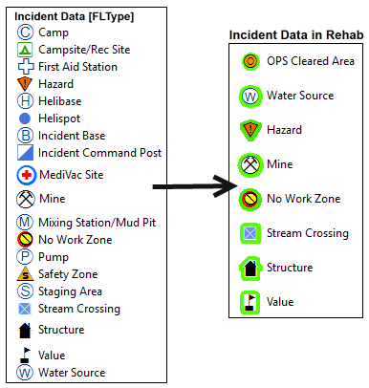
In the field the Rehab Specialist will decide one of two options for each Incident Point:
- Assign a rehab treatment or assign ‘No Treatment’. ‘No Treatment’ points should remain on the map.
- Verify potential safety issues identified in the incident data (eg. No Work Zone, Hazard, Mine, etc.), as necessary.

Rehab Points
This is a list of typical rehab treatments. Depending on the specific situation on a particular fire and the rehabilitation to be undertaken, many of these potential treatments may not apply.
Rehab Point Treatment Options:
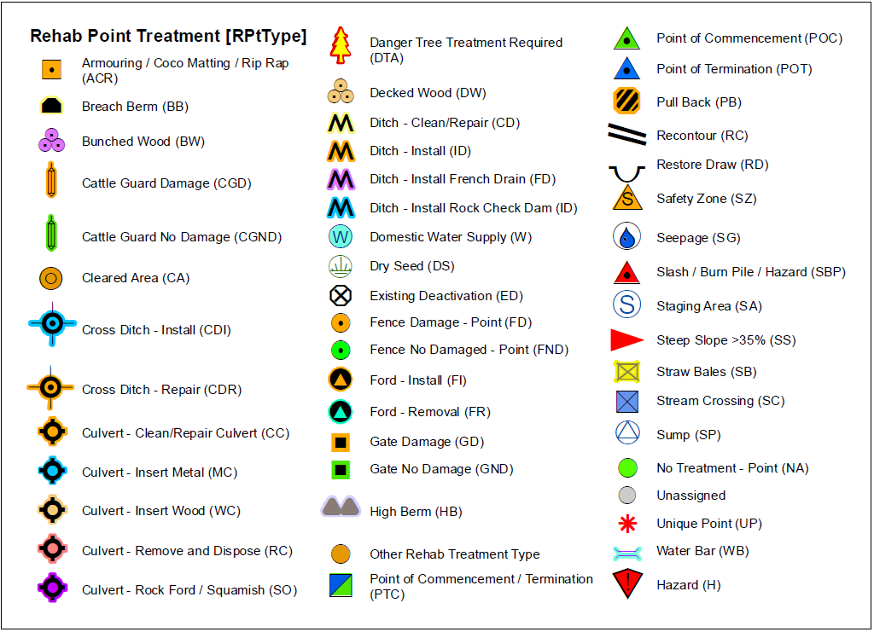

Lines

Incident Lines
The list below shows which incident lines will be selected to be migrated into the rehab database. Only those with [Status] set to ‘Current’ will be migrated. Unlike the points, the lines will not keep their original symbology as they will be grouped into the new categories with the new colours indicated below. [Status] will be changed to ‘Rehab - Requires Field Verification’.
Incident Line Type [FLType]
Completed Handline
Completed Fuel Free
Completed Line
Completed Machine Line
Containment/Control Line
Contingency Line
Proposed Machine Line
Fire Break Planned or Incomplete
Line Break Complete
Planned Fire Line
Planned Secondary Line
Highlighted Geographic Feature
Highlighted Manmade Feature
Other
Pipeline / Hazard
Road - Modified Existing
Trail

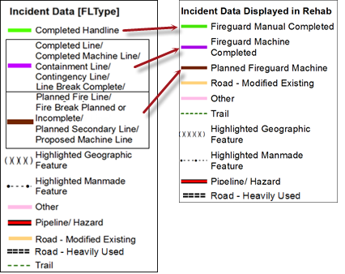
Rehab Lines
Rehab Line Treatment Options:
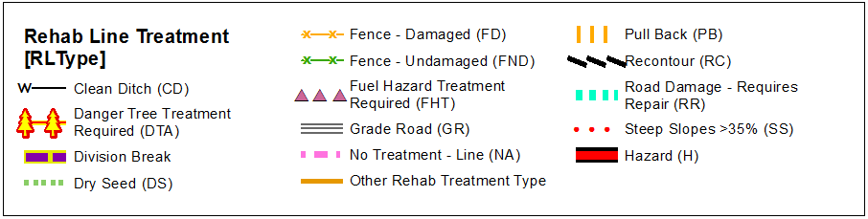

Depending on the specific situation on a particular fire and the rehabilitation to be undertaken, many of these potential treatments may not apply.

Polygons
Incident Polygon
Incident Poly Type [FPType]
No Work Zone
Only one polygon feature is typically migrated from the Incident database to the rehab database.

Rehab Polygon
Rehab treatment options that are unrelated to control lines may also be identified as rehab polygons.
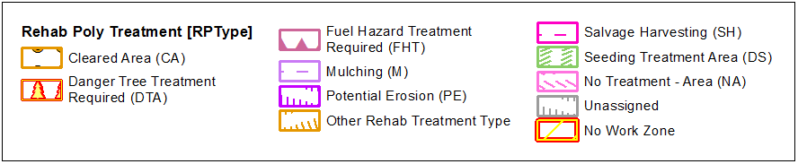

High Priority Points/Lines
Specific points or lines may be identified as a high priority point or a high priority line for rehabilitation. High priority points/lines are areas where there is a high risk of unintended consequences if rehab work is not undertaken prior to the next high intensity rainfall event and/or spring freshet.

The GIS and Rehab Specialists should work together to identify potential high priority areas:
- Rehab points, lines, and/or polygons are identified by the Rehab Specialist in the field as a high priority (e.g. stream blockage, fireguard constructed on unstable soils or erodible soils on steep slopes, archaeological find, etc.). A unique identifier(s) for the map label should be determined by the Rehab Specialist, otherwise, one will be assigned by the GIS Specialist.
- Map based information identified by the GIS Specialist as potential high priority is limited to:
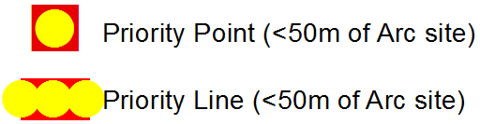
A point feature where a rehab point/line crosses an archaeological site or is within 50 meters of an archaeological site. This may also include rehab treatments within High and/or Moderate Archaeological Potential Polygons depending on the local circumstances/protocols.

Take special note that archaeological data is restricted and sensitive in nature. Do not place data or maps with archaeological data (Arc Potential or RAAD data/Archaeological Sites) on an external FTP site, unless the file is password protected and only if the contractors/licencee has the appropriate data sharing agreement in place. Do not release paper copies or data to unauthorized parties. Refer back to the FMP Catalogue for further details.

Note: In the past this section included Streams that were fish bearing but due to data source issues this has been put on hold.

Maps/GIS Products
Maps and GIS products can be requested from the GIS Specialist who is providing mapping support on the incident. Maps will include standard basemap features and other features that are of interest to Rehab Specialists. Standard basemap features include: Roads, Hydrology, Critical Infrastructure, First Nations, Land Ownership, Parks, Tenures, Client Agreement, Archaeological Sites, High and Moderate Archaeological Potential Polygons, terrain stability, Safety Features and Range Improvements (eg. fences), etc. A legend of the standard basemap features is included below:

Other GIS Products
For other GIS products of interest, please inform Kyle.Miller@gov.bc.ca or Steve.Richards@gov.bc.ca. so that these products could possibly be added as an option with consistent standards.

Many different map products and tables can potentially be produced and a few examples are provided below:
- Field Maps (Avenza)
- Plotter Maps (Poster size)
- High Priority Maps
- Overview Maps
- PID Maps (Private Parcels)

Data and Records Management
Take special note that some data is restricted and sensitive in nature. Do not place data or maps with archaeological data (Arc Potential or RAAD data/Archaeological Sites) on an external FTP site, unless the file is password protected and only if the contractors/licencee has the appropriate data sharing agreement in place. Do not release paper copies or data to unauthorized parties. Refer back to the FMP Catalogue for further details.

References, Resources and Links
Wildfire Rehabilitation Hub – Contact Steve Richards for credentials (Steve.Richards@gov.bc.ca)
FMP Catalogue

Document History
Version | Change Made | Effective Date
1.1 | Krista Northcott/Mike Black/Devona Hay | 2018/08/01
1.2 | Krista Northcott/Mike Black/Devona Hay | 2018/08/31
1.3 | Krista Northcott/ | 2019/04/06
1.4 | Steve Richards | 2022/04/07

Approvals

